Git Hands-on 4 – Merge Conflict Resolution
Step 1: Verify Repository Status
Command Used:
git status
Description:
Verified that the repository was in a clean state before creating a new branch.
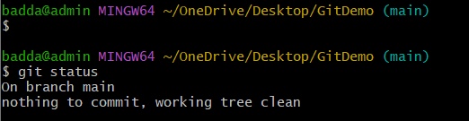
Step 2: Create Branch and Commit Changes
Commands Used:
git checkout -b GitWork
git add hello.xml
git commit -m "Added hello.xml in GitWork"
Description:
Created a new branch named GitWork, added hello.xml, and committed the changes.
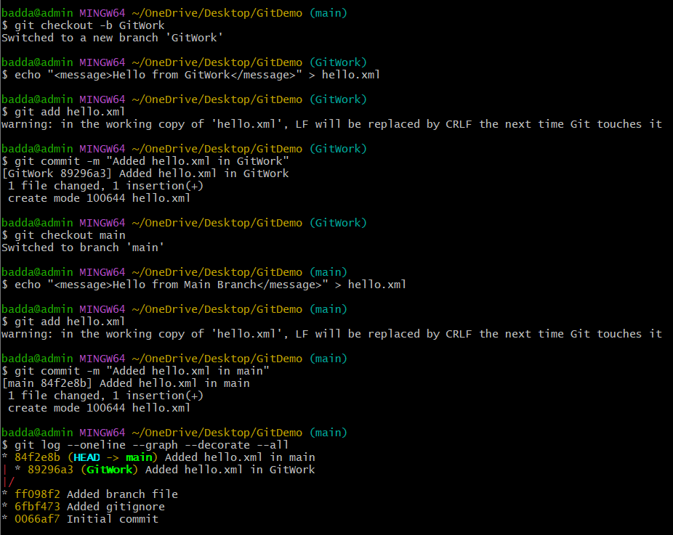

Step 3: Merge and Resolve Conflict
Commands Used:
git checkout main
git merge GitWork
Description:
Merged the GitWork branch into the main branch and resolved the merge conflict in hello.xml.
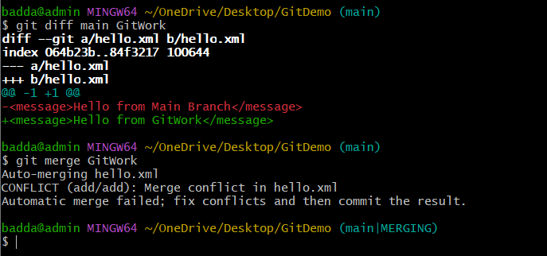

Step 4: Verify Final Repository Status
Commands Used:
git status
Description:
Verified that the merge was completed successfully and the working tree was clean.
